

Circuit Playground Express

*Importing and Downloading Files*

This manual describes how to download the code for a project, save it to your computer, and load it onto a Circuit Playground Express, and how to upload a saved file to open it again on the MakeCode site (http://makecode.adafruit.com).

There are two reasons to download your code: You must download your code to load it onto your Circuit Playgound Express. And it is also very important to regularly download the projects you are working on. MakeCode uses "cookies" in your browser to save the projects you've worked on most recently, but it's very easy for them to be lost (for example if you clear your browser's cache), so it's important to regularly download them as a backup.

Downloading a project

From the MakeCode project page, click the “Download” button to download a copy of your project as a ".uf2" file.

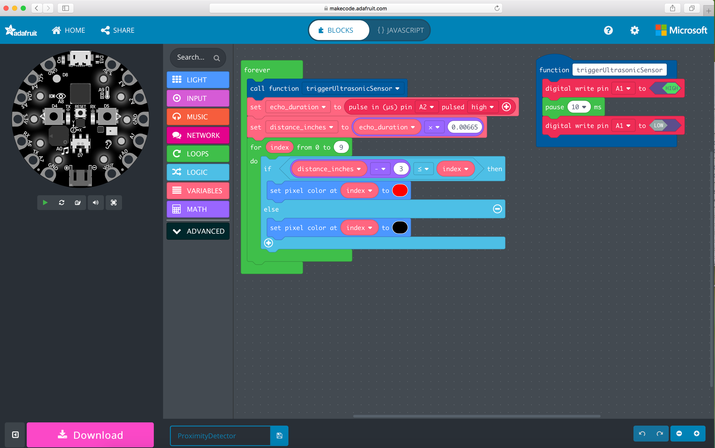

You may notice that the downloaded files are labeled "Untitled" - if you'd like your files to have a more descriptive name, you can enter a title into the blue text input to the right of the "Download" button.

Loading a project onto a Circuit Playground Express

Once your MakeCode project has been downloaded to your computer as a ".uf2" file, you can load it onto your Circuit Playground Express. Helpfully, the MakeCode website gives you instructions for loading the downloaded file onto your Circuit Playground Express when you click "Download":

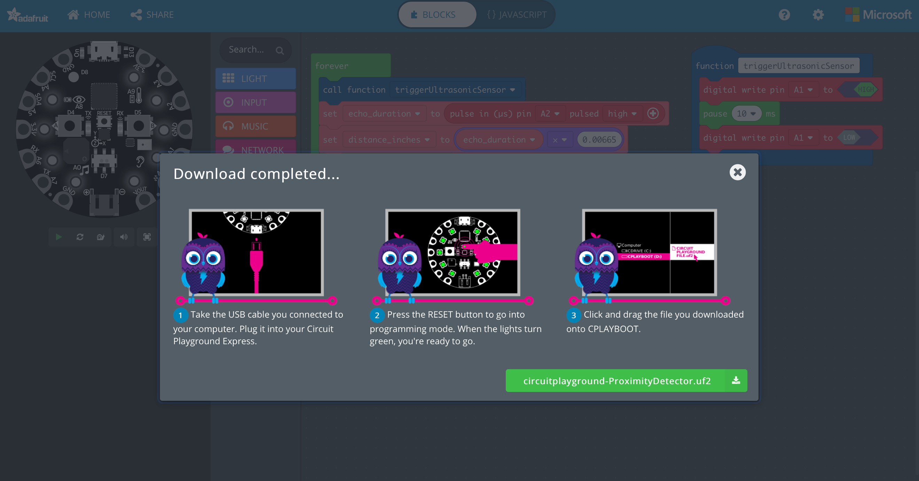

1. Your Circuit Playground Express must be connected to the computer using a USB cable.

2. Press the "Reset" button in the center of your Circuit Playground Express to put it in "bootloader" mode, which makes it ready to load a new program and makes your computer see it as a USB drive that it can copy a file onto. Rarely, pressing "Reset" fails to put the Circuit Playground Express into "bootloader" mode; if this happens, try quickly pressing "Reset" twice.

3. Find the downloaded file in your file browser, and drag and drop it onto the Circuit Playground Express, which should appear as "CPLAYBOOT". If you are using Windows, "CPLAYBOOT" should appear in the list of drives in the left-hand sidebar of your file explorer. If you are using Mac, it should appear on your desktop.

It will take a moment for the program to load. When your program is loaded it will immediately begin running, and you are ready to test your code! Note that your computer might complain at this point that you have disconnected a USB drive without ejecting it; that's normal and is nothing to worry about.

It is important to remember that you have to repeat this process every time you make changes to your code and want to test them on your Circuit Playground Express!

Importing a saved project

The following are instructions on how to import previously created MakeCode “.uf2” files and how to download program files onto your CP Express.

1. On the MakeCode website (<https://makecode.adafruit.com>), click the "Import" button

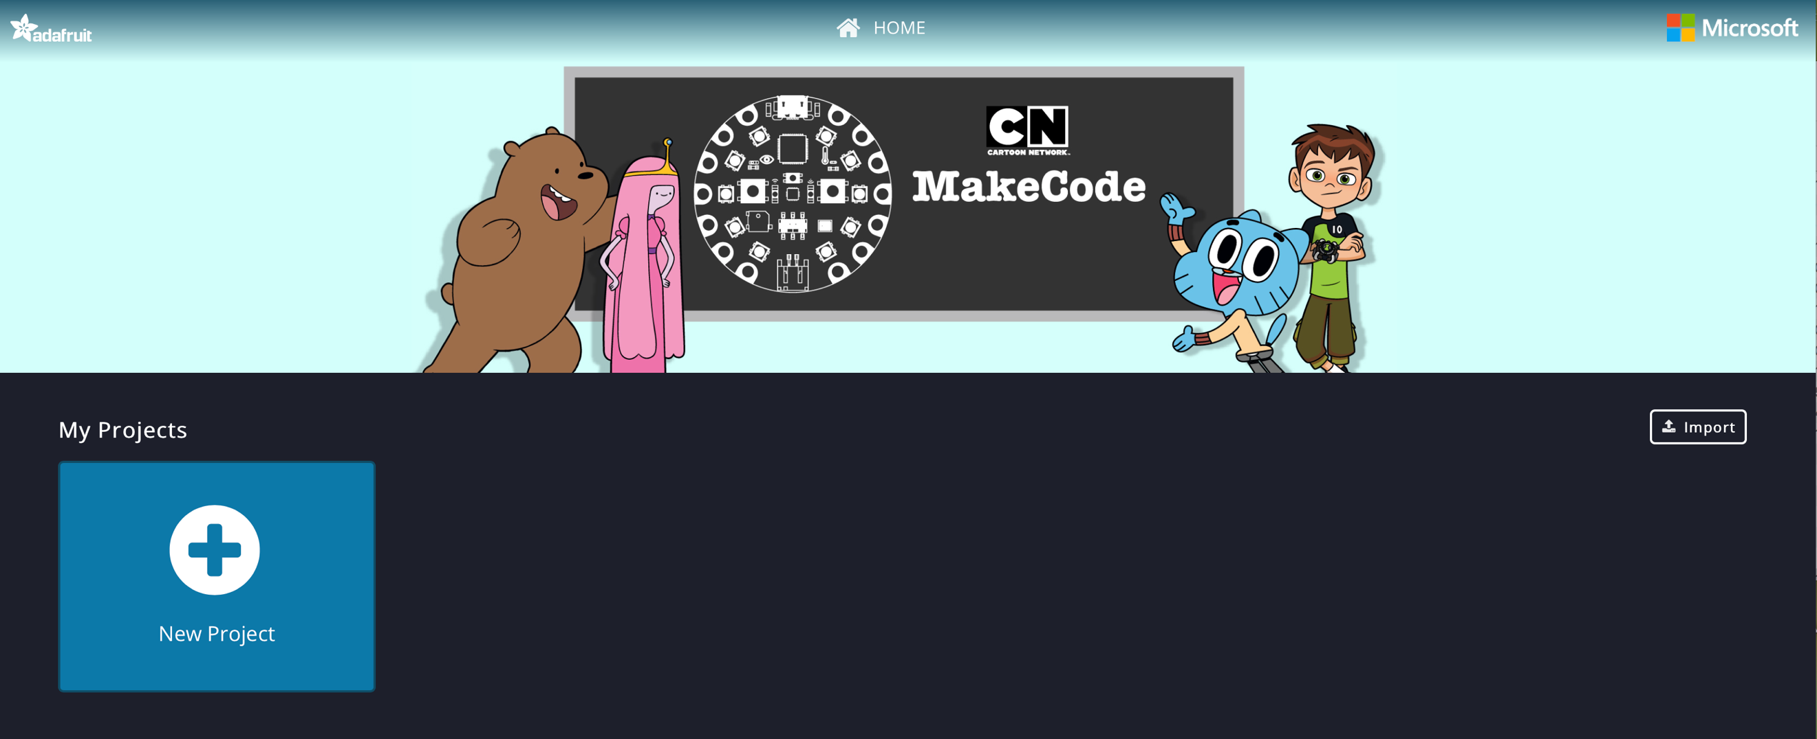

1. Select “Import File”, then "Choose File" in the following dialog.

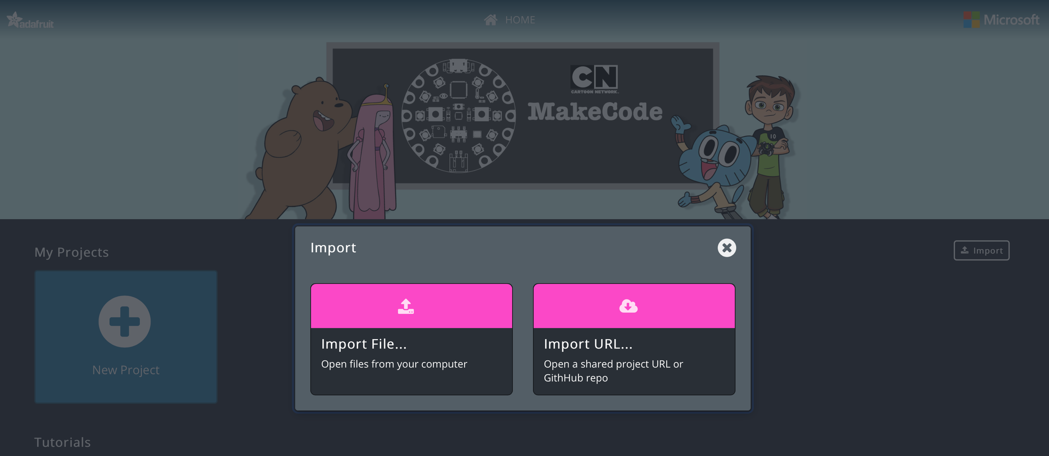

1. Find the file on your computer, then select “Choose” in the open file dialog box.
2. Complete the upload, by clicking on “Go Ahead”. The file will automatically be uploaded.

